30.Write a Python program to create bar plot of scores by group and gender.
Use multiple X values on the same chart for men and women.
Program:
import matplotlib.pyplot as plt
import numpy as np

men = [22, 30, 35, 35, 26]
women = [25, 32, 30, 35, 29]

x = np.arange(5)
width = 0.35

plt.bar(x - width/2, men, width, label="Men")
plt.bar(x + width/2, women, width, label="Women")

plt.xlabel("Groups")
plt.ylabel("Scores")
plt.title("Scores by Group and Gender")
plt.xticks(x, ["G1", "G2", "G3", "G4", "G5"])
plt.legend()

plt.show()

Output:
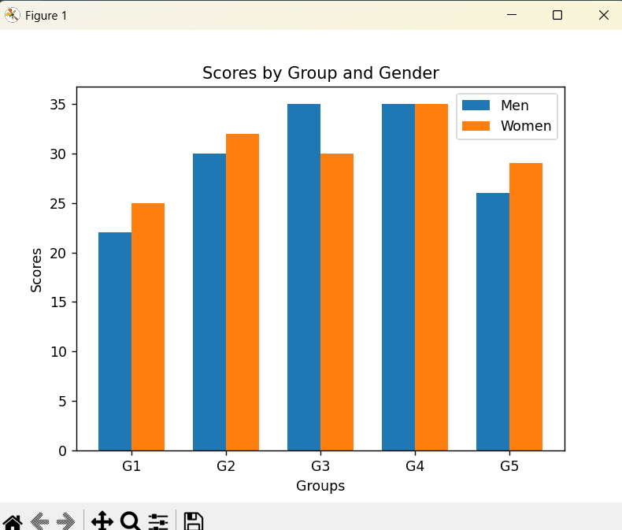

31.Write a Python program to create a stacked bar plot with error bars.

Program:
import matplotlib.pyplot as plt

men = [22, 30, 35, 35, 26]
women = [25, 32, 30, 35, 29]

men_sd = [4, 3, 4, 1, 5]
women_sd = [3, 5, 2, 3, 3]

x = range(5)

plt.bar(x, men, yerr=men_sd, capsize=5, label="Men")
plt.bar(x, women, bottom=men, yerr=women_sd, capsize=5, label="Women")

plt.xlabel("Groups")
plt.ylabel("Scores")
plt.title("Stacked Bar Plot with Error Bars")
plt.xticks(x, ["G1", "G2", "G3", "G4", "G5"])
plt.legend()

plt.show()

Output:
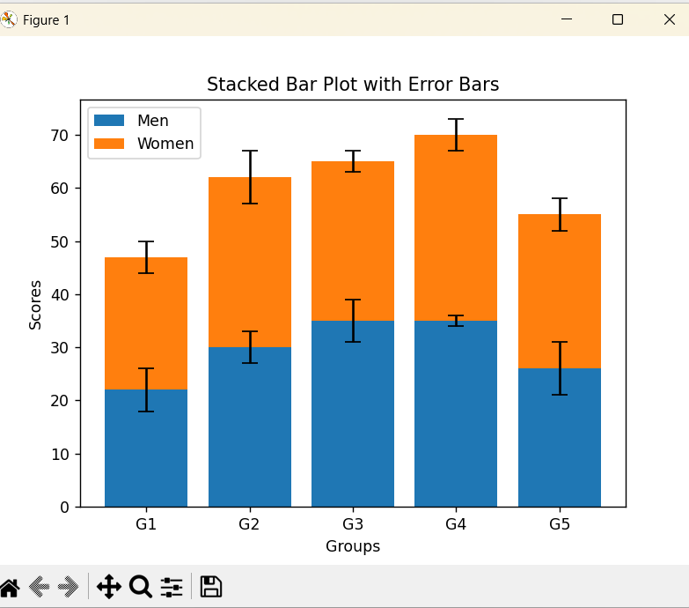

32.Write a Python program to draw a scatter graph taking a random
distribution in X and Y and plotted against each other.

Program:
import matplotlib.pyplot as plt
import numpy as np

x = np.random.rand(50)
y = np.random.rand(50)

plt.scatter(x, y)

plt.xlabel("X")
plt.ylabel("Y")
plt.title("Scatter Plot")

plt.show()

Output:
